### 4.3.4 COMPONENT DIAGRAM

It is Describes all components in a system, their interrelationships, interactions, and the  
interface of the system. It is an outline of the composition structure of components or  
modules

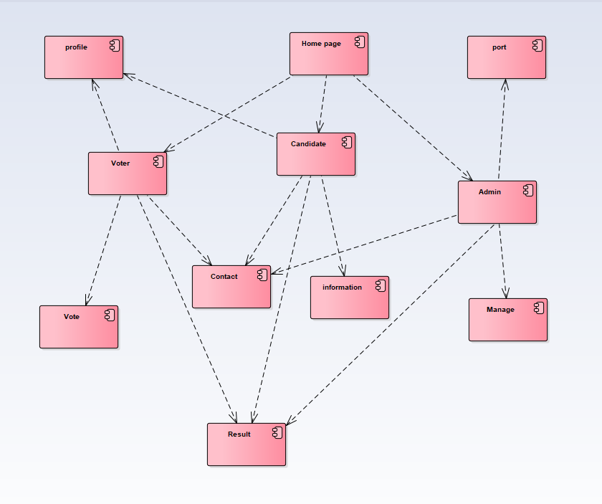

**Figure 31 Component diagram**